# 机器学习基础及凸优化

参考：<http://cvxopt.org/userguide/coneprog.html>

# 凸函数

## **1.1 Optimization Categories**

### 1.1.1 convex or non-convex

* Global optimization or better local optimization
* convex set：假设对于任意x，y∈C并且任意参数，a∈[0,1]，我们对ax+(1-a)y∈C <https://zhuanlan.zhihu.com/p/92230334>
* Convex Function define：函数的定义域domf为凸集，对于定义域里任意x，y，函数满足f(θx + (1-θy))<=θf(x)+(1-θ)f(y)   
   <https://www.zhihu.com/question/20014186/answer/27194360>

### 1.1.2 continuous or discrete

### 1.1.3 constraint or non-constraint

### 1.1.4 smooth or non-smooth

## **1.2 问题解决过程：**

* Decision Variable
* Objective Function
* Constraint
* 判断类型
* 设计或使用

## **1.3 应用**

* LP：Transportation(运输) Problem: min Transportation cost minf s.t. 条件
* portfolio optimization:10万块钱-->买多支股票 Mean Variance portfolio optimization
* set cover problem：找最少集合的个数
* Exhaustive Search :枚举(NP-hard的时候可用)
* Greedy search：Local method-->global optimization
* non-convex --> relax -->convex

# duality（对偶）：视角不同-->minimize primal and maximize dual(见图，理想情况下会相遇) 凹函数

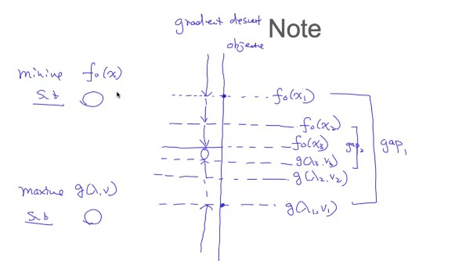

* primal-->dual

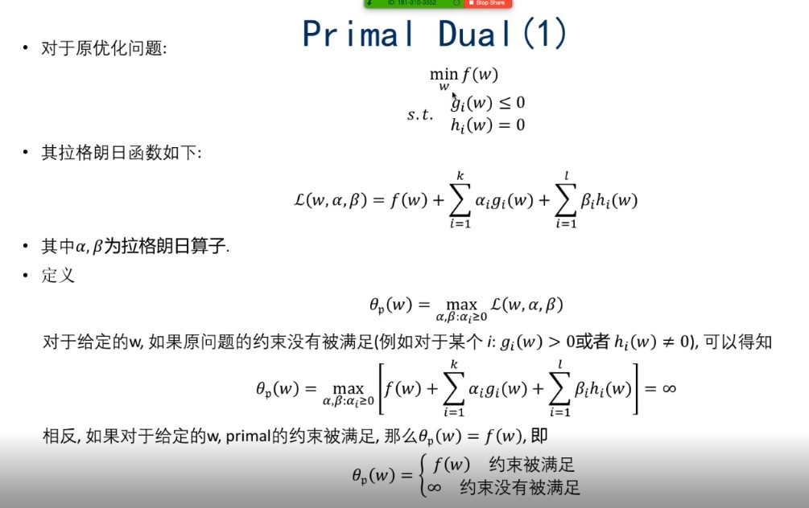

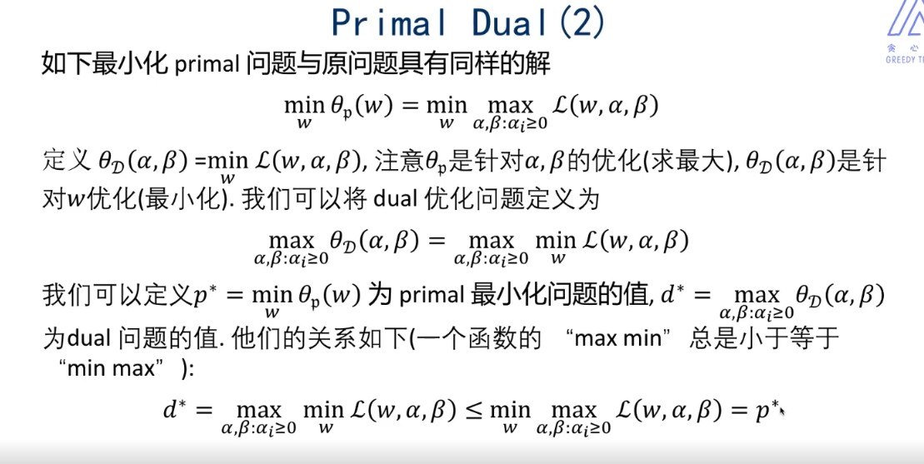

* Lower bound property：P*>=d*
* Strong and weak Duality：结果可能不一样
* strong条件：Conplementary Slackness

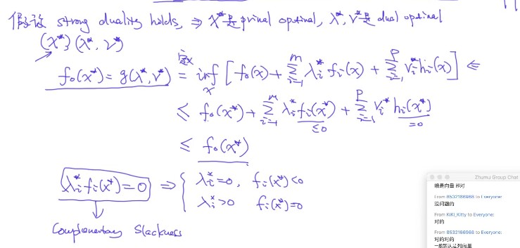

## 2.1 strong条件：KKT conditions

